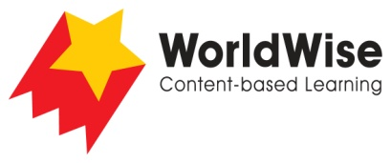

Levels N–P – Investigations
Finding Our Way
Part 5 – Communicate and share ideas
Look over all of the information that you have gathered in your investigation.
What are the most important ideas about your investigation?
Make a chart showing the most important ideas.
How we improved our maps
Features | Zoo 1 | Zoo 2 | Museum 1 | Museum 2
Labels
Directions
Direction arrows
Icons to show where things are
Colour coding
Icons to show where things are
Entrances and exits
Other

Once completed, make sure you save this file.

