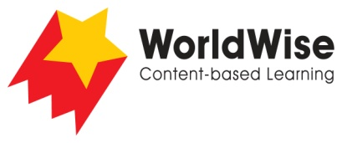

Levels N–P – Investigations
From Me to You

Part 3 – Record and analyse data
Find a way of recording your information that will allow you to see any patterns in the data.

How do people personally communicate with others?
What has assisted their personal communication?
What body language is used?
How do signs and symbols help the way we communicate?
What ways have people personally written to each other?
How do people communicate across long distances?
How did people use to communicate across long distances?

Once completed, make sure you save this file.

