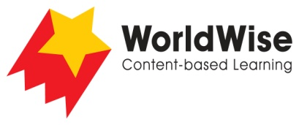

Levels N–P – Investigations
Don’t Throw It Away!

Part 5 – Communicate and share ideas
Look over all the information that you have gathered in your investigation.
What are the most important ideas about your topic?
Make a chart showing the most important ideas.

 | Home rubbish | Neighbourhood rubbish | City rubbish | Ocean rubbish
How is this rubbish created?
What harm does it do?
What environmental problems occur in these places?
How can this rubbish be reduced?
How is technology being used to assist in reducing rubbish?
How can we help?
Once completed, make sure you save this file.

