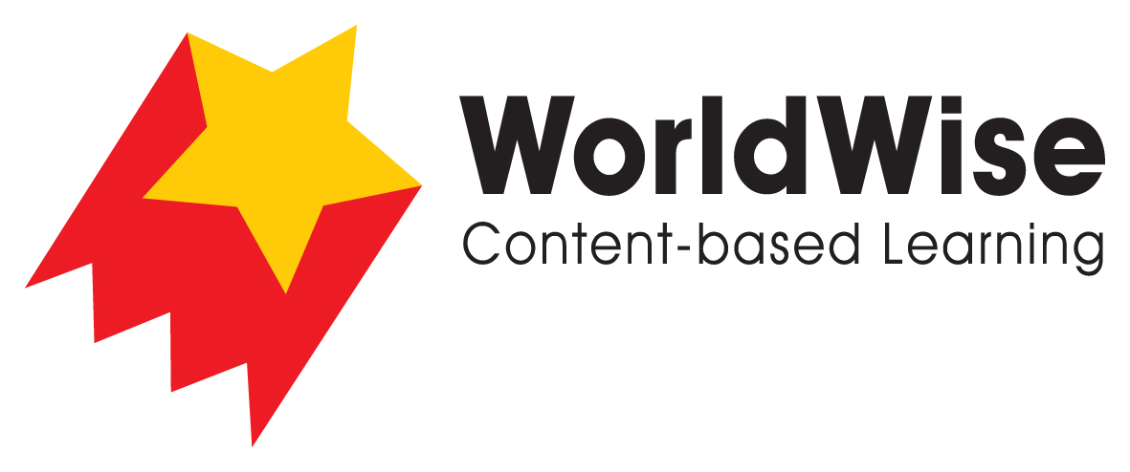

Levels T–V – Investigations
Science for the People

Part 5 – Communicate and share ideas
Look over all of the information that you have gathered in your investigation.
What are the most important ideas about involving people in scientific research?
Make a chart showing the most important ideas.
 | Rachel Carson | Sally Ride
Why was their scientific work important?
How did they convince others?
What is similar in the ways they spread their ideas?
Why did people engage with their ideas?
How have technological developments changed the way people interact with and assist scientists?
Why is citizen science important?
Once completed, make sure you save this file.

