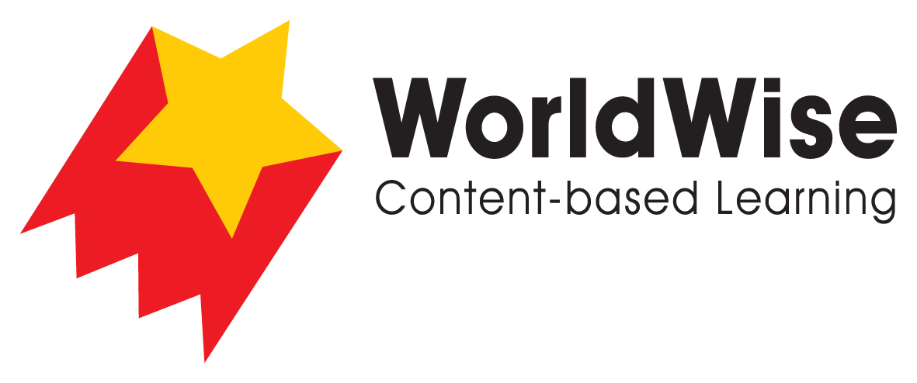

Levels T–V – Investigations
Saving the Amazon River
Part 3 – Record and analyse data
Find a way of recording your information that will allow you to see any pattern
in this data.

Amazon River
Where does this river begin?
What countries does it move through?
What ocean does it meet?
Why is it important to the animals that live there?
Why is it important to the people that live there?
What are the threats to this river system?
What can people do to prevent these changes?
Once completed, make sure you save this file.

